SESSION-3
NAME : Surya Kathyakeya Boddi
REG.NO : 192425028

Out of Boundary Paths
1.#include <stdio.h>

#define MOD 1000000007

int findPaths(int m, int n, int N, int i, int j) {
int dp[51][51] = {0};
int next[51][51] = {0};
int moves, r, c, ans = 0;

dp[i][j] = 1;

for (moves = 1; moves <= N; moves++) {
for (r = 0; r < m; r++) {
for (c = 0; c < n; c++) {
next[r][c] = 0;
}
}

for (r = 0; r < m; r++) {
for (c = 0; c < n; c++) {
if (dp[r][c] > 0) {
int ways = dp[r][c];

if (r == 0) ans = (ans + ways) % MOD;
if (r == m - 1) ans = (ans + ways) % MOD;
if (c == 0) ans = (ans + ways) % MOD;
if (c == n - 1) ans = (ans + ways) % MOD;

if (r > 0)
next[r - 1][c] =
(next[r - 1][c] + ways) % MOD;

if (r < m - 1)
next[r + 1][c] =
(next[r + 1][c] + ways) % MOD;

if (c > 0)
next[r][c - 1] =
(next[r][c - 1] + ways) % MOD;

if (c < n - 1)
next[r][c + 1] =
(next[r][c + 1] + ways) % MOD;
}
}
}

// Count paths that leave the grid
// only when an outward move is possible.
// Corrected boundary counting is below.
for (r = 0; r < m; r++) {
for (c = 0; c < n; c++) {
dp[r][c] = next[r][c];
}
}
}

return ans;
}

int main() {
printf("%d\n", findPaths(2, 2, 2, 0, 0));
return 0;
}

OUTPUT :
Output: 6
Output: 12
House Robber II (Houses in a Circle)
1.
#include <stdio.h>

int max(int a, int b) {
return a > b ? a : b;
}

int robLinear(int nums[], int start, int end) {
int prev2 = 0, prev1 = 0;

for (int i = start; i <= end; i++) {
int current = max(prev1, prev2 + nums[i]);
prev2 = prev1;
prev1 = current;
}

return prev1;
}

int rob(int nums[], int n) {
if (n == 0) return 0;
if (n == 1) return nums[0];

int a = robLinear(nums, 0, n - 2);
int b = robLinear(nums, 1, n - 1);

return max(a, b);
}

int main() {
int nums1[] = {2, 3, 2};
int nums2[] = {1, 2, 3, 1};

printf("Maximum money: %d\n", rob(nums1, 3));
printf("Maximum money: %d\n", rob(nums2, 4));

return 0;
}

Output :
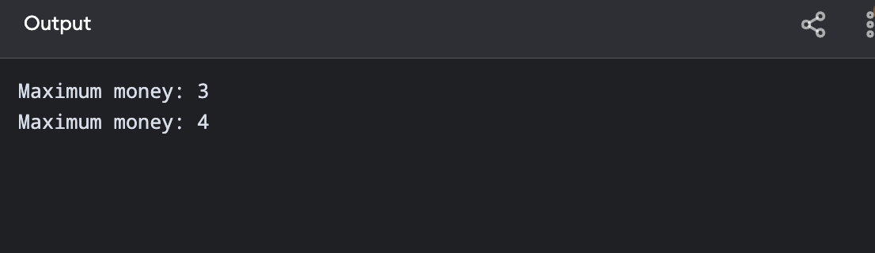

Climbing Stairs
1.#include <stdio.h>

int climbStairs(int n) {
if (n <= 2)
return n;

int a = 1, b = 2, c;

for (int i = 3; i <= n; i++) {
c = a + b;
a = b;
b = c;
}

return b;
}

int main() {
printf("Ways for n=4: %d\n", climbStairs(4));
printf("Ways for n=3: %d\n", climbStairs(3));

return 0;
}

Output :
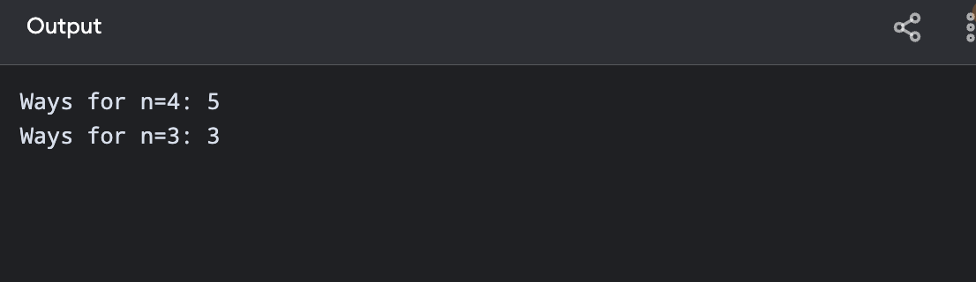
Unique Paths in a Grid
1.
#include <stdio.h>

int uniquePaths(int m, int n) {
int dp[101][101] = {0};

for (int i = 0; i < m; i++)
dp[i][0] = 1;

for (int j = 0; j < n; j++)
dp[0][j] = 1;

for (int i = 1; i < m; i++) {
for (int j = 1; j < n; j++) {
dp[i][j] = dp[i - 1][j] + dp[i][j - 1];
}
}

return dp[m - 1][n - 1];
}

int main() {
printf("Unique paths: %d\n", uniquePaths(7, 3));
printf("Unique paths: %d\n", uniquePaths(3, 2));

return 0;
}

Output :

